# Status Report # 4

Report Date

February 12, 2016

Progress Overview

During this period we were successfully able to complete the complete basic CRUD features of the API. We can now register users, log them in and add details about other things such as files and computers.

During this period we’ve also started work on the desktop user client and the website for displaying files. Currently the desktop client allows users to login and register with the service and the websites lists all uploaded files.

During this period the database has been modified to meet unseen requirements in the program and is currently on its final working version. We don’t foresee any more required to changes to its structure.

Budget Overview

## Cost Overview as of February 12, 2016

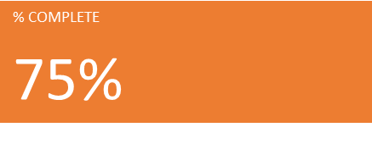M9JR4-GNTQM-HBT6Q-KVQWF-MWPC

## Cost Status for all top-level tasks

Outstanding Issues/Purposed Solutions

**Issue #1:** The file upload controller allows the upload of multiple files at the same time. It should only allow one.

**Issue #1 Purposed Solution:** Check the field name of an upload request and only process files with a given field name.

Change Requests

There are currently no pending or active change requests.

Plans For Next Period

During the next period our goal is to get the server side API done. We’d like to complete our file uploading and downloading endpoints and these are the last two big ones we need to work on.

We also plan during the next period to work on the desktop client application. This is one of our highest priorities as it’s essential that users have a way to interact with our service. Our goal is to have a basic version of this working to demo, and then to continue to improve it.

We plan to get the website done during the next period as well. The website has already been started and can currently list files and their details. During the next period we need to implement download pages and files preview pages.

We aim to have this project completed by next Friday, February the 19th.